1. Display TreatmentId, and TreatmentName for every treatment which id is ‘TM001’ or ‘TM002’.

SELECT TreatmentId,TreatmentName

FROM MsTreatment

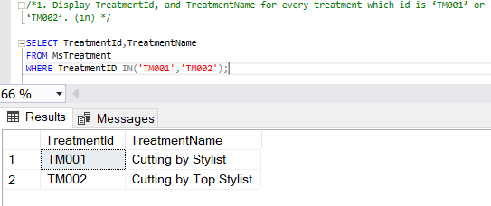WHERE TreatmentID IN('TM001','TM002');

2. Display TreatmentName, and Price for every treatment which type is not ‘Hair Treatment’ and ‘Message / Spa’.

SELECT TreatmentName,Price

FROM MsTreatment INNER JOIN MsTreatmentType ON MsTreatment.TreatmentTypeId = MsTreatmentType.TreatmentTypeId

WHERE TreatmentTypeName NOT IN('Hair Treatment','Massage / Spa');

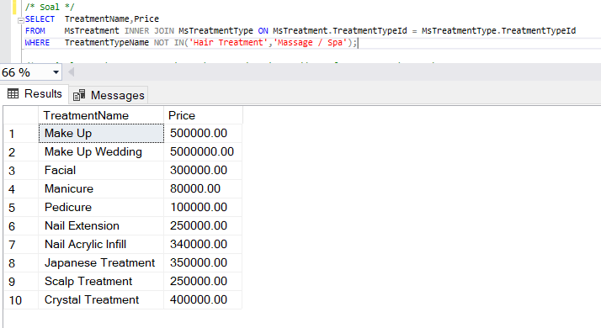

3. Display CustomerName, CustomerPhone, and CustomerAddress for every customer whose name is more than 8 charactes and did transaction on Friday.

SELECT CustomerName,CustomerPhone,CustomerAddress

FROM MsCustomer INNER JOIN HeaderSalonServices ON MsCustomer.CustomerId = HeaderSalonServices.CustomerId

WHERE LEN(CustomerName) > 8 AND DATENAME(WEEKDAY,TransactionDate) = 'Friday'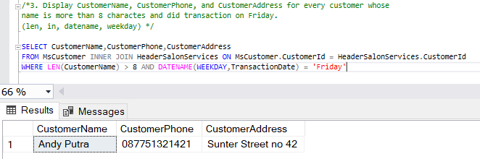

4. Display TreatmentTypeName, TreatmentName, and Price for every treatment that taken by customer whose name contains ‘Putra’ and happened on day 22th .

SELECT TreatmentTypeName,TreatmentName,Price

FROM MsTreatmentType

INNER JOIN MsTreatment ON MsTreatmentType.TreatmentTypeId = MsTreatment.TreatmentTypeId

INNER JOIN DetailSalonServices ON MsTreatment.TreatmentId = DetailSalonServices.TreatmentId

INNER JOIN HeaderSalonServices ON DetailSalonServices.TransactionId = HeaderSalonServices.TransactionId

INNER JOIN MsCustomer ON HeaderSalonServices.CustomerId = MsCustomer.CustomerId

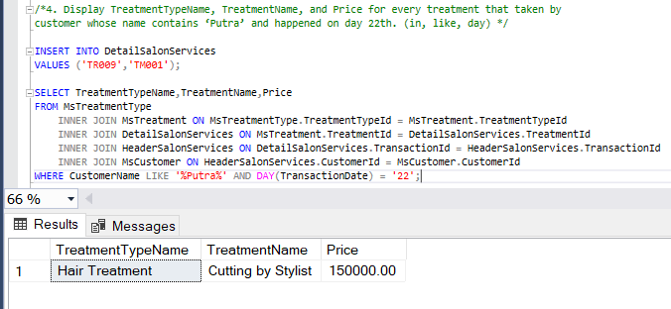WHERE CustomerName LIKE '%Putra%' AND DAY(TransactionDate) = '22';

5. Display StaffName, CustomerName, and TransactionDate (obtained from TransactionDate in ‘Mon dd,yyyy’ format) for every treatment which the last character of treatmentid is an even number.

SELECT MsTreatment.TreatmentId,CustomerName,

CONVERT(VARCHAR,TransactionDate,107) AS TransactionDate

FROM HeaderSalonServices

INNER JOIN MsCustomer ON HeaderSalonServices.CustomerId = MsCustomer.CustomerId

INNER JOIN MsStaff ON HeaderSalonServices.StaffId = MsStaff.StaffId

INNER JOIN DetailSalonServices ON HeaderSalonServices.TransactionId = DetailSalonServices.TransactionId

INNER JOIN MsTreatment ON DetailSalonServices.TreatmentId = MsTreatment.TreatmentId

WHERE EXISTS(SELECT MsTreatment.TreatmentId

FROM MsTreatment

WHERE MsTreatment.TreatmentId = DetailSalonServices.TreatmentId AND

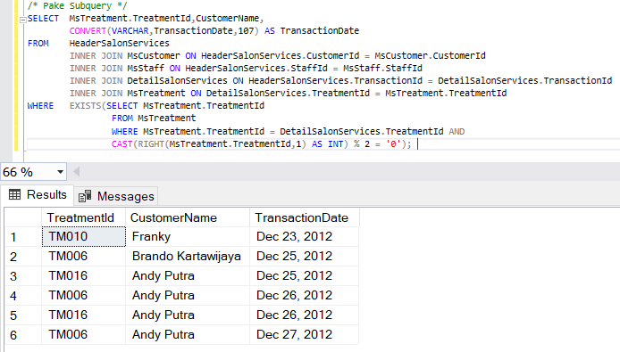 CAST(RIGHT(MsTreatment.TreatmentId,1) AS INT) % 2 = '0');

Saya sudah menemukan solusi dari permasalahan waktu asistensi, jadi saya tambahkan WHERE MsTreatment.TreatmentId = DetailSalonServices.TreatmentId pada subquerynya.

6. Display CustomerName, CustomerPhone, and CustomerAddress for every customer that was served by staff whose name’s length is an odd number.

SELECT CustomerName,CustomerPhone,CustomerAddress

FROM MsCustomer

WHERE EXISTS(SELECT StaffName

FROM MsStaff

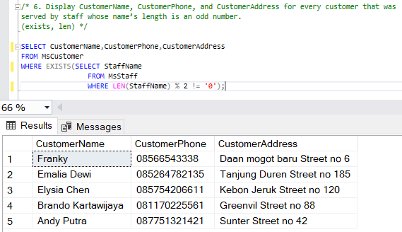WHERE LEN(StaffName) % 2 != '0');

7. Display ID (obtained form last 3 characters of StaffID), and Name (obtained by taking character after the first space until character before second space in StaffName) for every staff whose name contains at least 3 words and hasn’t served male customer .

SELECT RIGHT(StaffId,3) AS ID,

SUBSTRING(StaffName,CHARINDEX(' ',StaffName)+1,CHARINDEX(' ',StaffName,CHARINDEX(' ',StaffName))+1 ) AS [Name]

FROM MsStaff

WHERE LEN(StaffName) - LEN(REPLACE(StaffName,' ','')) + 1 > 2 AND

EXISTS(SELECT CustomerGender

FROM MsCustomer

WHERE CustomerGender NOT LIKE 'Male');

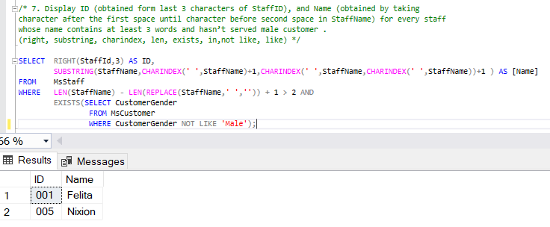

8. Display TreatmentTypeName, TreatmentName, and Price for every treatment which price is higher than average of all treatment’s price.

SELECT TreatmentTypeName, TreatmentName, Price, alias.Average

FROM MsTreatmentType INNER JOIN MsTreatment ON MsTreatmentType.TreatmentTypeId = MsTreatment.TreatmentTypeId

,(SELECT AVG(Price) AS Average FROM MsTreatment) AS alias

WHERE Price > alias.Average;

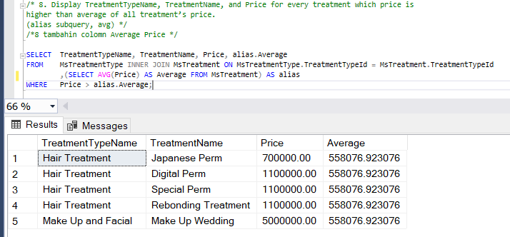

9. Display StaffName, StaffPosition, and StaffSalary for every staff with highest salary or lowest salary.

SELECT StaffName, StaffPosition, StaffSalary

FROM MsStaff, (SELECT MAX(StaffSalary) AS Maximum FROM MsStaff) AS highest,

(SELECT MIN(StaffSalary) AS Minimum FROM MsStaff) AS lowest

WHERE StaffSalary = highest.Maximum OR StaffSalary = lowest.Minimum;

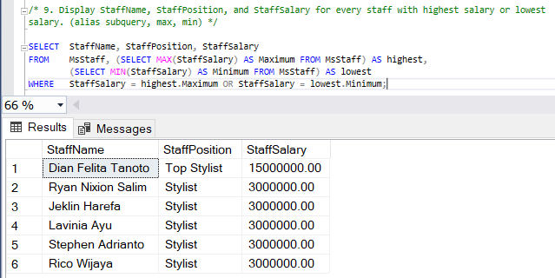

10. Display CustomerName,CustomerPhone,CustomerAddress, and Count Treatment (obtained from the total number of treatment) for every transaction which has the highest total number of treatment.

SELECT CustomerName, CustomerPhone, CustomerAddress,

COUNT(MsTreatment.TreatmentId) AS [Count Treatment]

FROM MsCustomer

INNER JOIN HeaderSalonServices ON MsCustomer.CustomerId = HeaderSalonServices.CustomerId

INNER JOIN DetailSalonServices ON HeaderSalonServices.TransactionId = DetailSalonServices.TransactionId

INNER JOIN MsTreatment ON DetailSalonServices.TreatmentId = MsTreatment.TreatmentId,

(SELECT MAX(TT.TotalTreatment) AS Maximum FROM

(SELECT COUNT(MsTreatment.TreatmentId) AS TotalTreatment FROM

MsCustomer, DetailSalonServices, HeaderSalonServices, MsTreatment

WHERE HeaderSalonServices.CustomerId = MsCustomer.CustomerId AND

DetailSalonServices.TransactionId = HeaderSalonServices.TransactionId AND

DetailSalonServices.TreatmentId = MsTreatment.TreatmentId

GROUP BY MsCustomer.CustomerName, MsCustomer.CustomerPhone, MsCustomer.CustomerAddress) AS TT) AS MX

GROUP BY CustomerName, CustomerPhone, CustomerAddress, MX.Maximum

HAVING COUNT(MsTreatment.TreatmentId) = MX.Maximum;

